**LIGHTS**

**RED,GREEN,YELLOW**

**RF Transmitter**

**Encoder**

**Circuit**

**Block Diagram of Transmitter Section**

**RF Receiver**

**UC**

**AT89C51**

**Decoder**

**Circuit**

**Motor**

**Driving Ckt**

**Block Diagram of Receiver Section**

**TRANSMITTER AND RECIEVER (ENCODER DECODER) CIRCUIT**

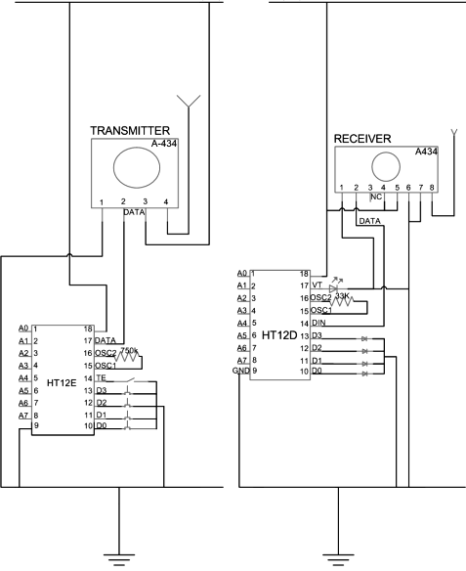

**CONTROLLER CIRCUIT AT RECEIVER SECTION**

